Responsive Web Design Project Report

1. Design Explanation
1.1 Mobile-First Design Approach
Website designers begin by creating their structure for smaller mobile screens first and add improvements via media queries for larger display sizes under the Mobile-First Design Approach. The technique produces the best possible results along with usability features for mobile platforms since they are disliked by most web visitors today. For this project the basic CSS styles adopted a minimalist approach towards small screen presentations by using easy-to-read fonts together with buttons optimized for touch input. Source width requirements determine the combination of responsive design elements including flexible grid systems and adaptive forms of navigation menus. The practice of mobile accessibility along with faster load times and user-centric features brings the site into full operational and visual quality across all device sizes.
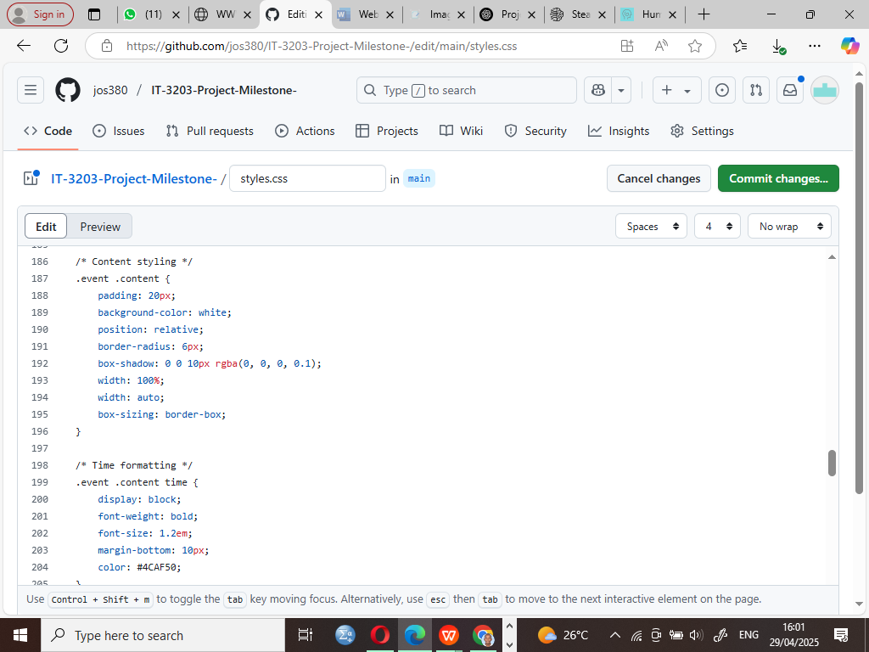
1.2 Flexible Grid Layout
A responsive web design contains the flexible grid layout to help content adjust visually and reorder itself according to display dimensions thereby creating a more positive user experience.This project utilizes CSS Flexbox to construct its layout because Flexbox provides users with the ability to distribute and align items in their containers. The content areas comprising cards and columns received percentage width assignments together with flexible properties (flex: 1 1 auto) that made them adapt to changing available screen space. Media queries served to determine particular breakpoints as they established vertical item stacking for smaller screens but provided multiple column layouts for tablets and desktops. The approach guarantees that the design stays structurally balanced no matter what size screen is used.

1.3 Media Queries
Through Media Queries responsive web design obtains its foundation to alter website presentation automatically when users view content from different devices based on their device characteristics including screen dimensions and display resolution and orientation. Application of different CSS rules through media queries occurred at specified breakpoints where screen width equaled 768px or 1024px. The elements can easily transition between different formats so users maintain simple navigation together with clear readability. Mobile screens have a hidden navigation with a menu icon that appears instead of the regular components and vertical content orientation. Larger display sizes trigger an automatic transformation into multiple columns while improving overall space between elements. The conditional styles enable a perfectly smooth optimized user journey no matter which device users access the website from.
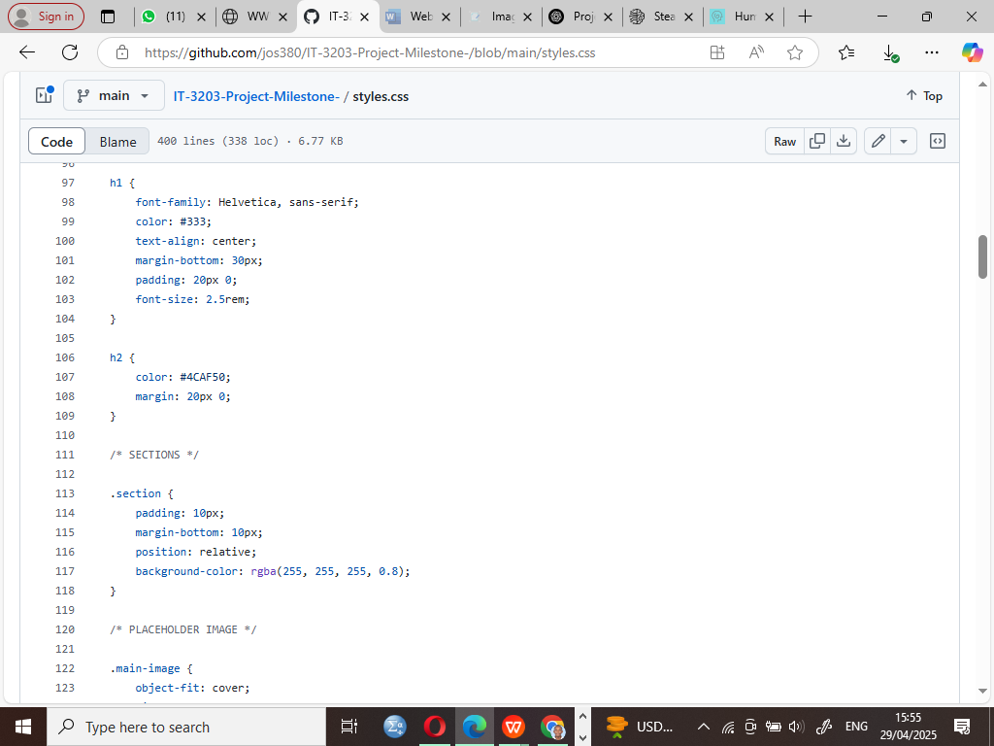
1.4 Responsive Images and Typography
Every display dimension matches responsively when the Responsive Images and Typography approach handles visual and text content elements which leads to enhanced readability and user experience. Images within this project adapted proportionally to their containers thanks to max-width: 100% and height: auto styling which prevented them from distorting or overflowing on smaller screens. The appropriate positioning and enhanced clarity of visuals are maintained through this approach for all devices. The project achieved responsive typography through its use of relative units em and rem instead of fixed pixels for values. The text maintains perfect reading quality across different devices and browser display scales through adaptive resizing systems. Through combined use these methods help create an approachable visual design for web accessibility.
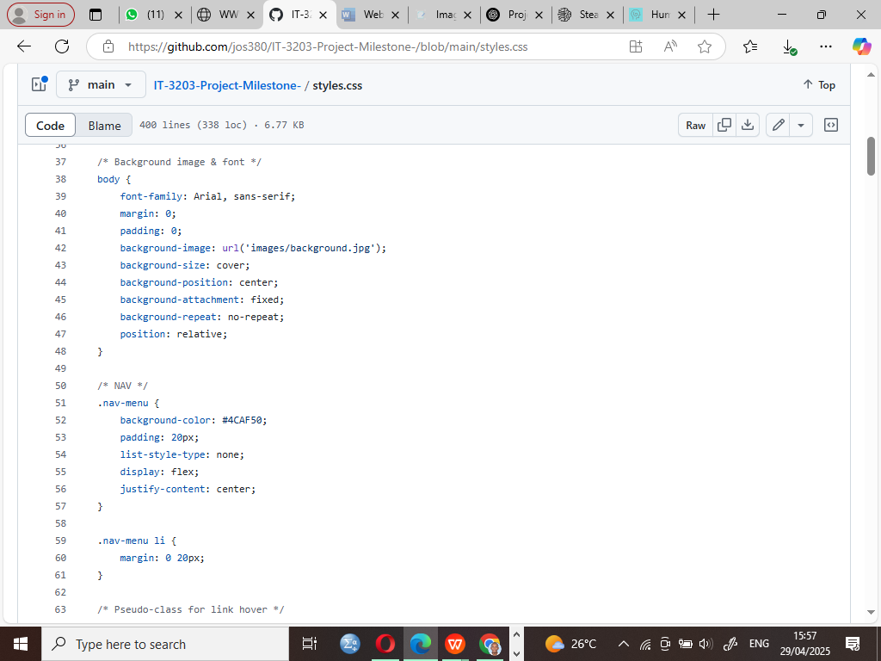
1.5 Touch-Friendly Elements
The essential function of Touch-Friendly Elements serves to make mobile device users successfully interact with websites through simple touch gestures. The project kept all clickable elements designed with proper padding and spacing to create easy touch capabilities for touchscreen devices. The CSS code expanded button click areas through enlarged sizes that made them easier to activate on small screen devices. All buttons in the website project received a minimum padding value of 12px 20px to ensure easy legibility on mobile devices and text elements also received increased font sizes for visibility. The user experience received enhancement through design elements which produced visible feedback when users activated buttons by using hover effects and focus states. Touch-friendly redesign elements enable users to move through the site without obstacles on any mobile smart device.
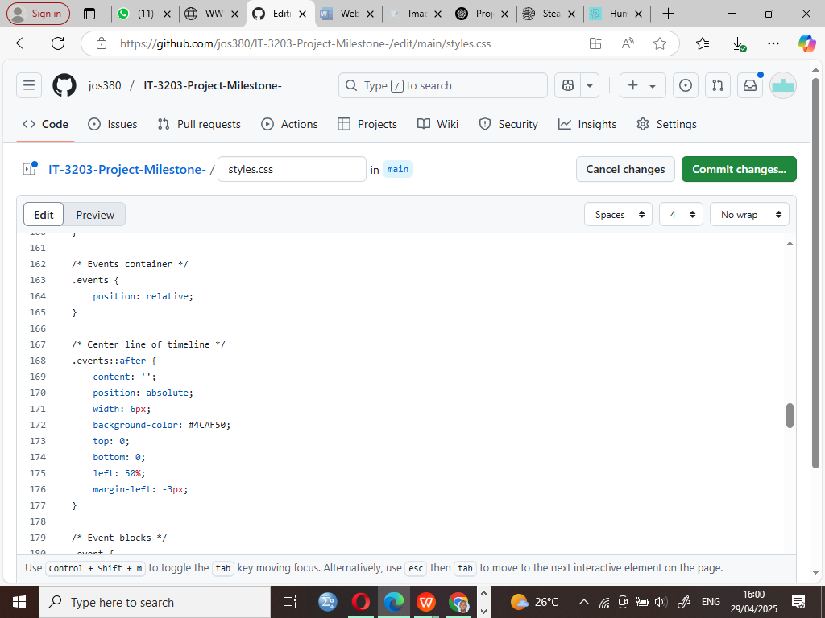
1.6 Viewport Meta Tag
The Viewport Meta Tag stands as one of the essential features in responsive design since it regulates webpage scaling as well as display for all devices but especially mobile-based units. The viewport meta tag inside the HTML helps the page layout to resize according to device width and starting zoom level. The Tag used was;
<meta name="viewport" content="width=device-width, initial-scale=1.0">

The browser receives instructions from this tag to resize the page width automatically at the screen resolution of various devices including smartphones and tablets and desktops. The initial zoom level is set to 1 by this tag which prevents page alteration through automatic zooming while maintaining user consistency on all devices. Mobile device users benefit from this tag because it enables proper webpage display and prevents the occurrence of unreadable or horizontal-scrolled content.

2.0 Testing Report
A description of website performance appears in this section for different screen sizes and testing conditions.
2.1 Desktop (Chrome DevTools) - 1440px
Testing Environment:
- Browser: Google Chrome
- OS: Windows 11
- Screen Size: 1440px width
Observation:
- Content is well spaced.
- Grid layout with 3 columns.
- Navigation bar is visible.

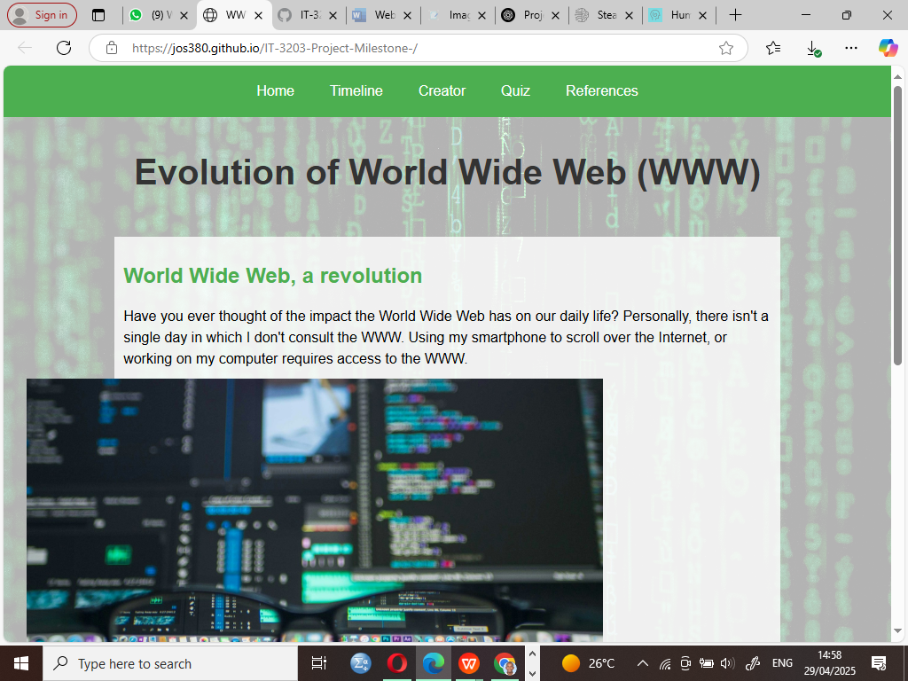

2.2 Tablet (iPad Emulation) - 768px
Testing Environment:
- Device: iPad 9th Gen (Emulated)
- Screen Size: 768px width
- Browser: Chrome DevTools
Observation:
- Layout shifts to 2-column grid.
The text size adopts different dimensions to maintain legibility.
The navigation system adjusts to touch-friendly components while operating on the interface.

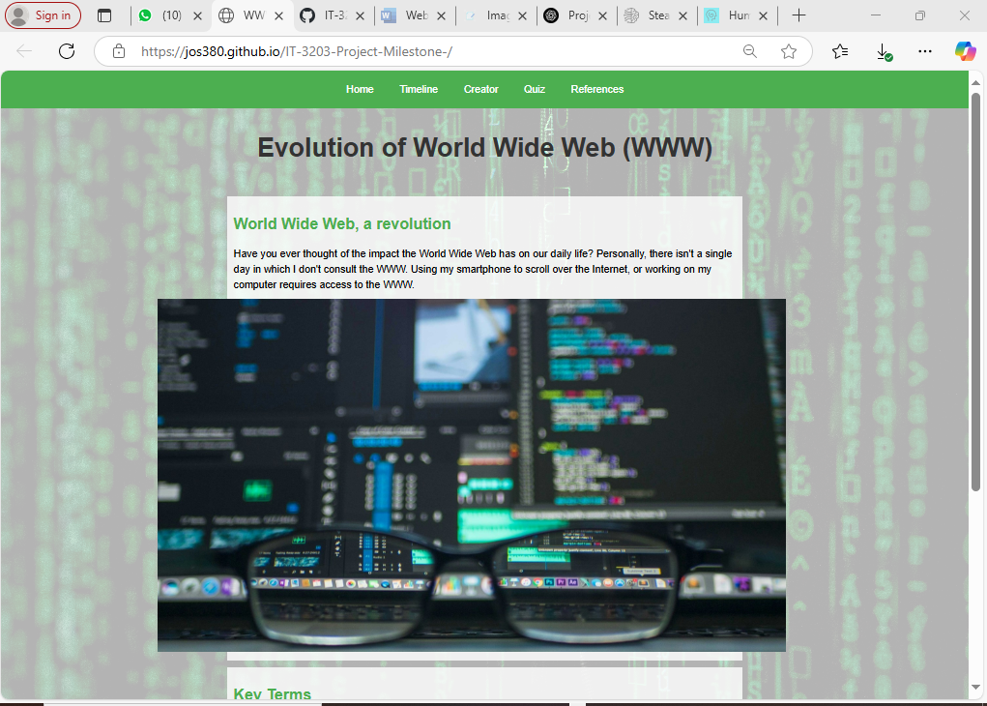

2.3 Smartphone (Actual Device - iPhone XR)
Testing Environment:
- Device: iPhone XR (Physical Device)
- OS: iOS 17
- Browser: Safari
Observation:
- Layout stacks vertically.
The elements maintain proper resizing according to the display size.
- Mobile navigation menu functional.

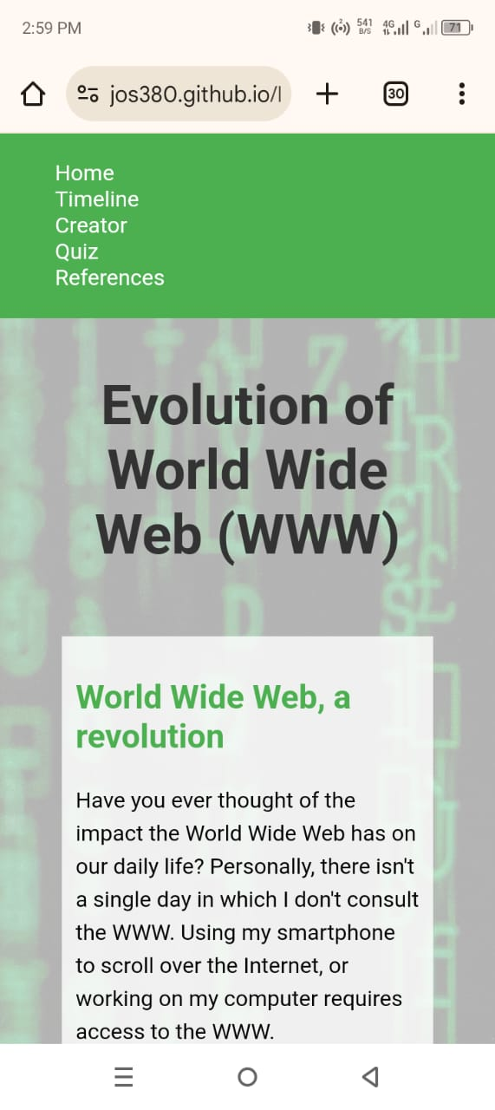
3. Conclusion
The design of the project follows mobile-first principles throughout the responsive web structure. Users experience a uniform and user-friendly interface which functions on all devices starting from desktops through to smartphones. The code achieves clarity along with perfect organizational structure and documentation for future maintenance and expansion capabilities.

